**Database system & web**

TUTORIAL 8

Avni Arora_20103153_B6

1)

CREATE PROCEDURE GCD()

BEGIN

DECLARE a INT;

DECLARE b INT;

DECLARE c INT DEFAULT 0;

DECLARE i INT DEFAULT 0;

SET a=20;

SET b=30;

WHILE i<=a AND i<=b DO

IF(a mod i=0 AND b mod i=0) THEN

SET c=i;

SET i=i+1;

ELSE

SET i=i+1;

END IF;

END WHILE;

SELECT c;

END$$

DELIMITER ;

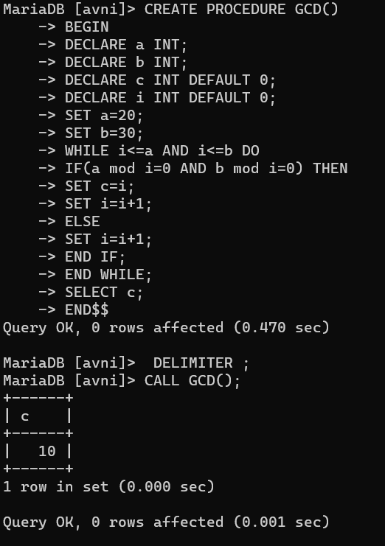

(After CALLING GCD)

CALL GCD();

**OUTPUT:**



2)

DELIMITER $$

CREATE PROCEDURE fact(IN n INT)

BEGIN

DECLARE f INT DEFAULT 1;

DECLARE i INT DEFAULT 1;

WHILE i<=n DO

SET f=f*i;

SET i=i+1;

END WHILE;

SELECT f AS FACTORIAL;

END$$

DELIMITER ;

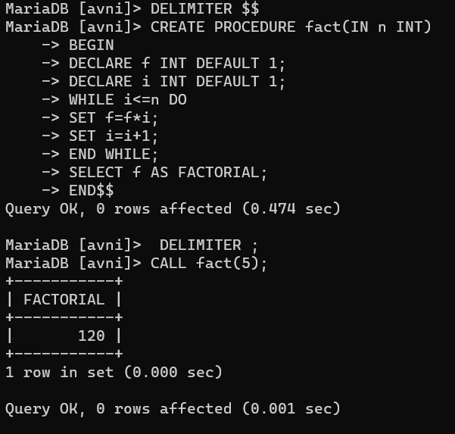

(After CALLING fact)

CALL fact(5);

**OUTPUT:**

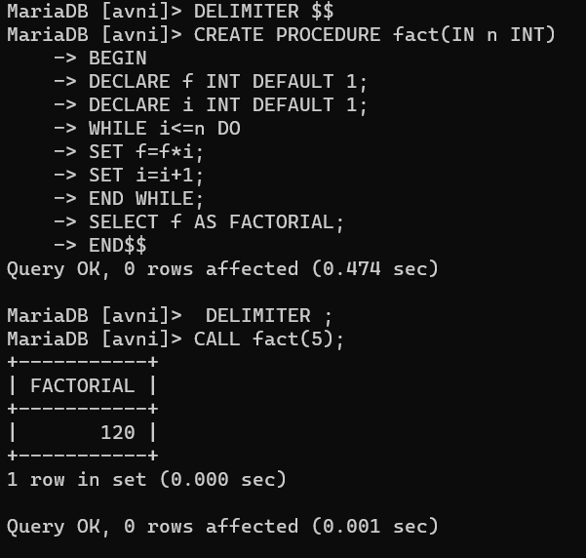

3)

Employee Table in database:

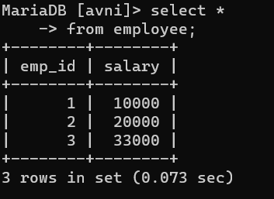

PROCEDURE CREATED:

DELIMITER $$

CREATE PROCEDURE increment_salary()

BEGIN

UPDATE employee

SET salary=salary*1.10;

END$$

DELIMITER ;

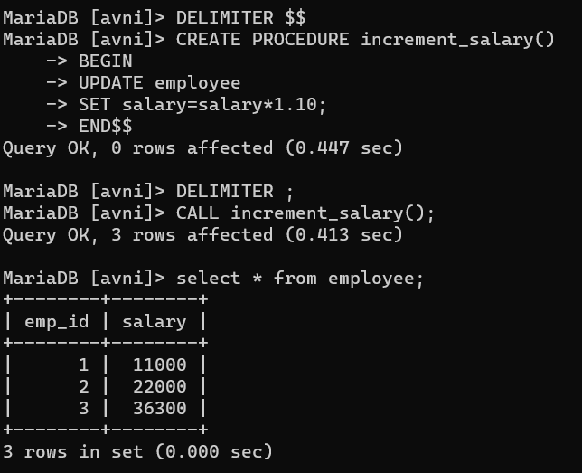

(After CALLING incremented_salary)

CALL incremented_salary();

**OUTPUT:**

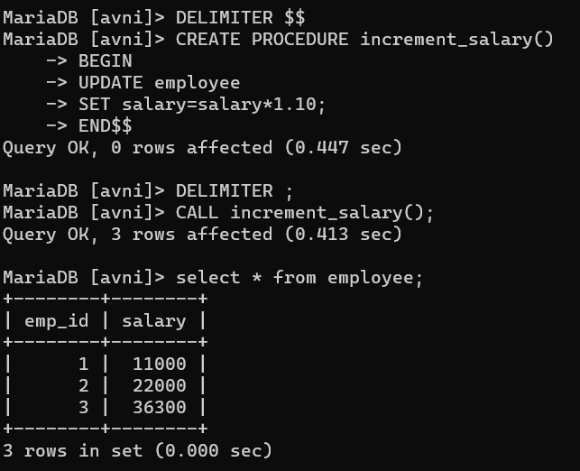

4)

DELIMITER $$

CREATE FUNCTION fibb(n INT)

RETURNS varchar(255)

BEGIN

DECLARE a INT DEFAULT 0;

DECLARE b INT DEFAULT 1;

DECLARE c INT ;

DECLARE i INT ;

DECLARE str VARCHAR(255);

SET str='0,1,';

SET i=2;

WHILE i<n DO

SET c=a+b;

SET str=CONCAT(str,c,',');

SET a=b;

SET b=c;

SET i=i+1;

END WHILE;

SELECT str;

END $$

DELIMITER ;

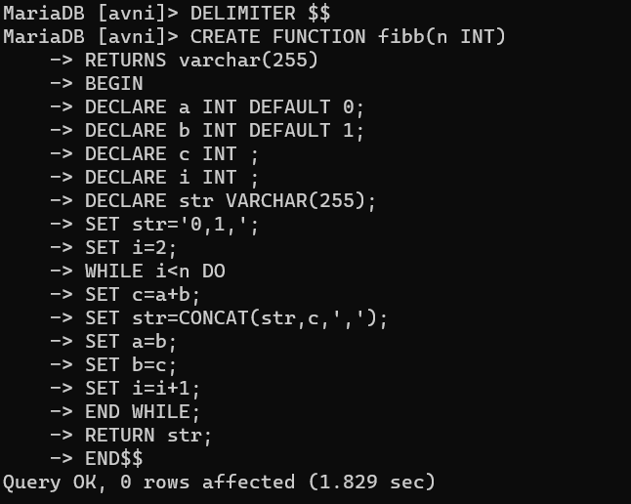

**CALLING FUNCTION:**

SET @series=fibb(5);

SELECT @series;

**OUTPUT:**

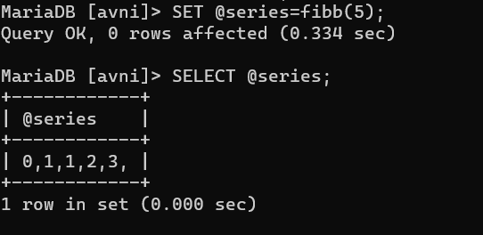

5)

Customers Table in database:

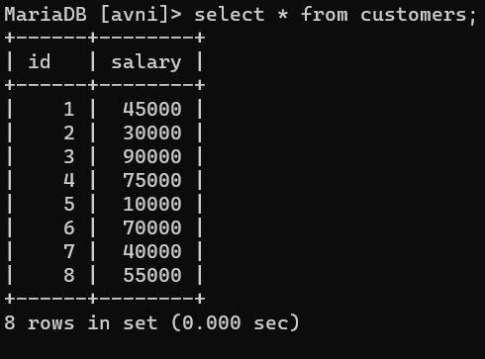

FUNCTION:

DELIMITER $$

CREATE FUNCTION count_cust()

RETURNS INT

BEGIN

DECLARE a int default 0;

SELECT Count(*) into a

from customers

where salary>40000;

RETURN a;

END $$

DELIMITER ;

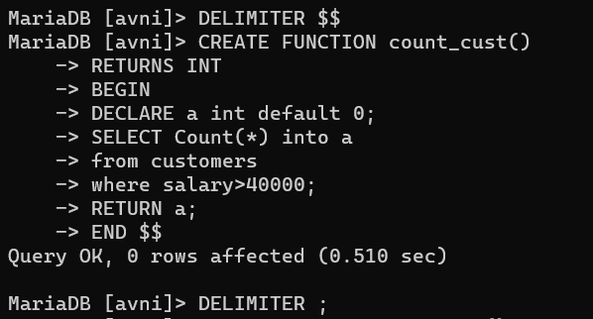

**CALLING FUNCTION:**

SET @count=count_cust();

SELECT @count;

**OUTPUT:**

